D-311 Unit 1: Decision Making and Situational Awareness

Unit Objectives:
- Define Situational Awareness.
- List six steps in the risk management (decision making) process.
- Describe why situational awareness is important to the IADP.
- List four factors that contribute to the loss of situational awareness.
- Describe two ways to strengthen your situational awareness.

Unit at a Glance:
Topics | Method | Approx. Time
Objectives | Presentation | 5 Minutes
Define Situational Awareness | Presentation / Group Discussion | 10 Minutes
6 Steps to Risk Management | Presentation / Group Discussion | 15 Minutes
Importance of Situational Awareness | Presentation / Group Discussion | 10 Minutes
Factors that Contribute to loss of Situational Awareness | Presentation / Group Discussion | 10 Minutes
Strengthening Situational Awareness | Presentation / Group Discussion | 10 Minutes
Total Time |  | Total 60 Minutes

Course Materials:
- Computer
- Unit 1 Instructor Guide
- Unit 1 PowerPoint

Classroom:
- Ability to display images and video on large screens.
- White board or easel access for group discussions.

Slide1
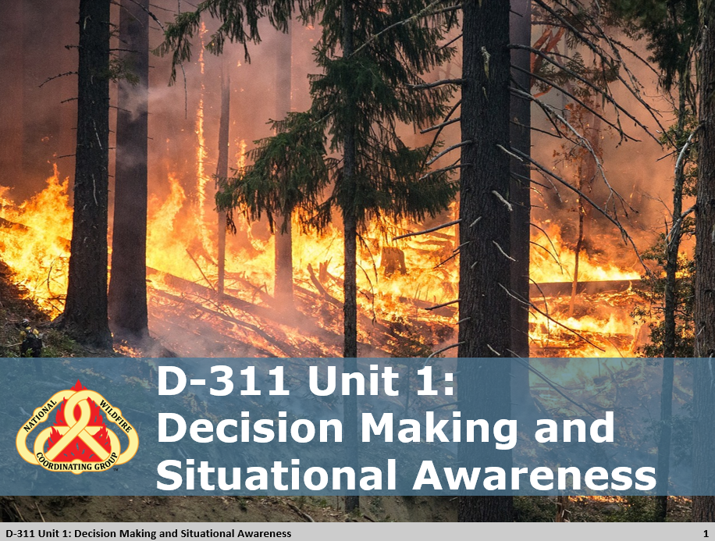

Slide 2 Objectives
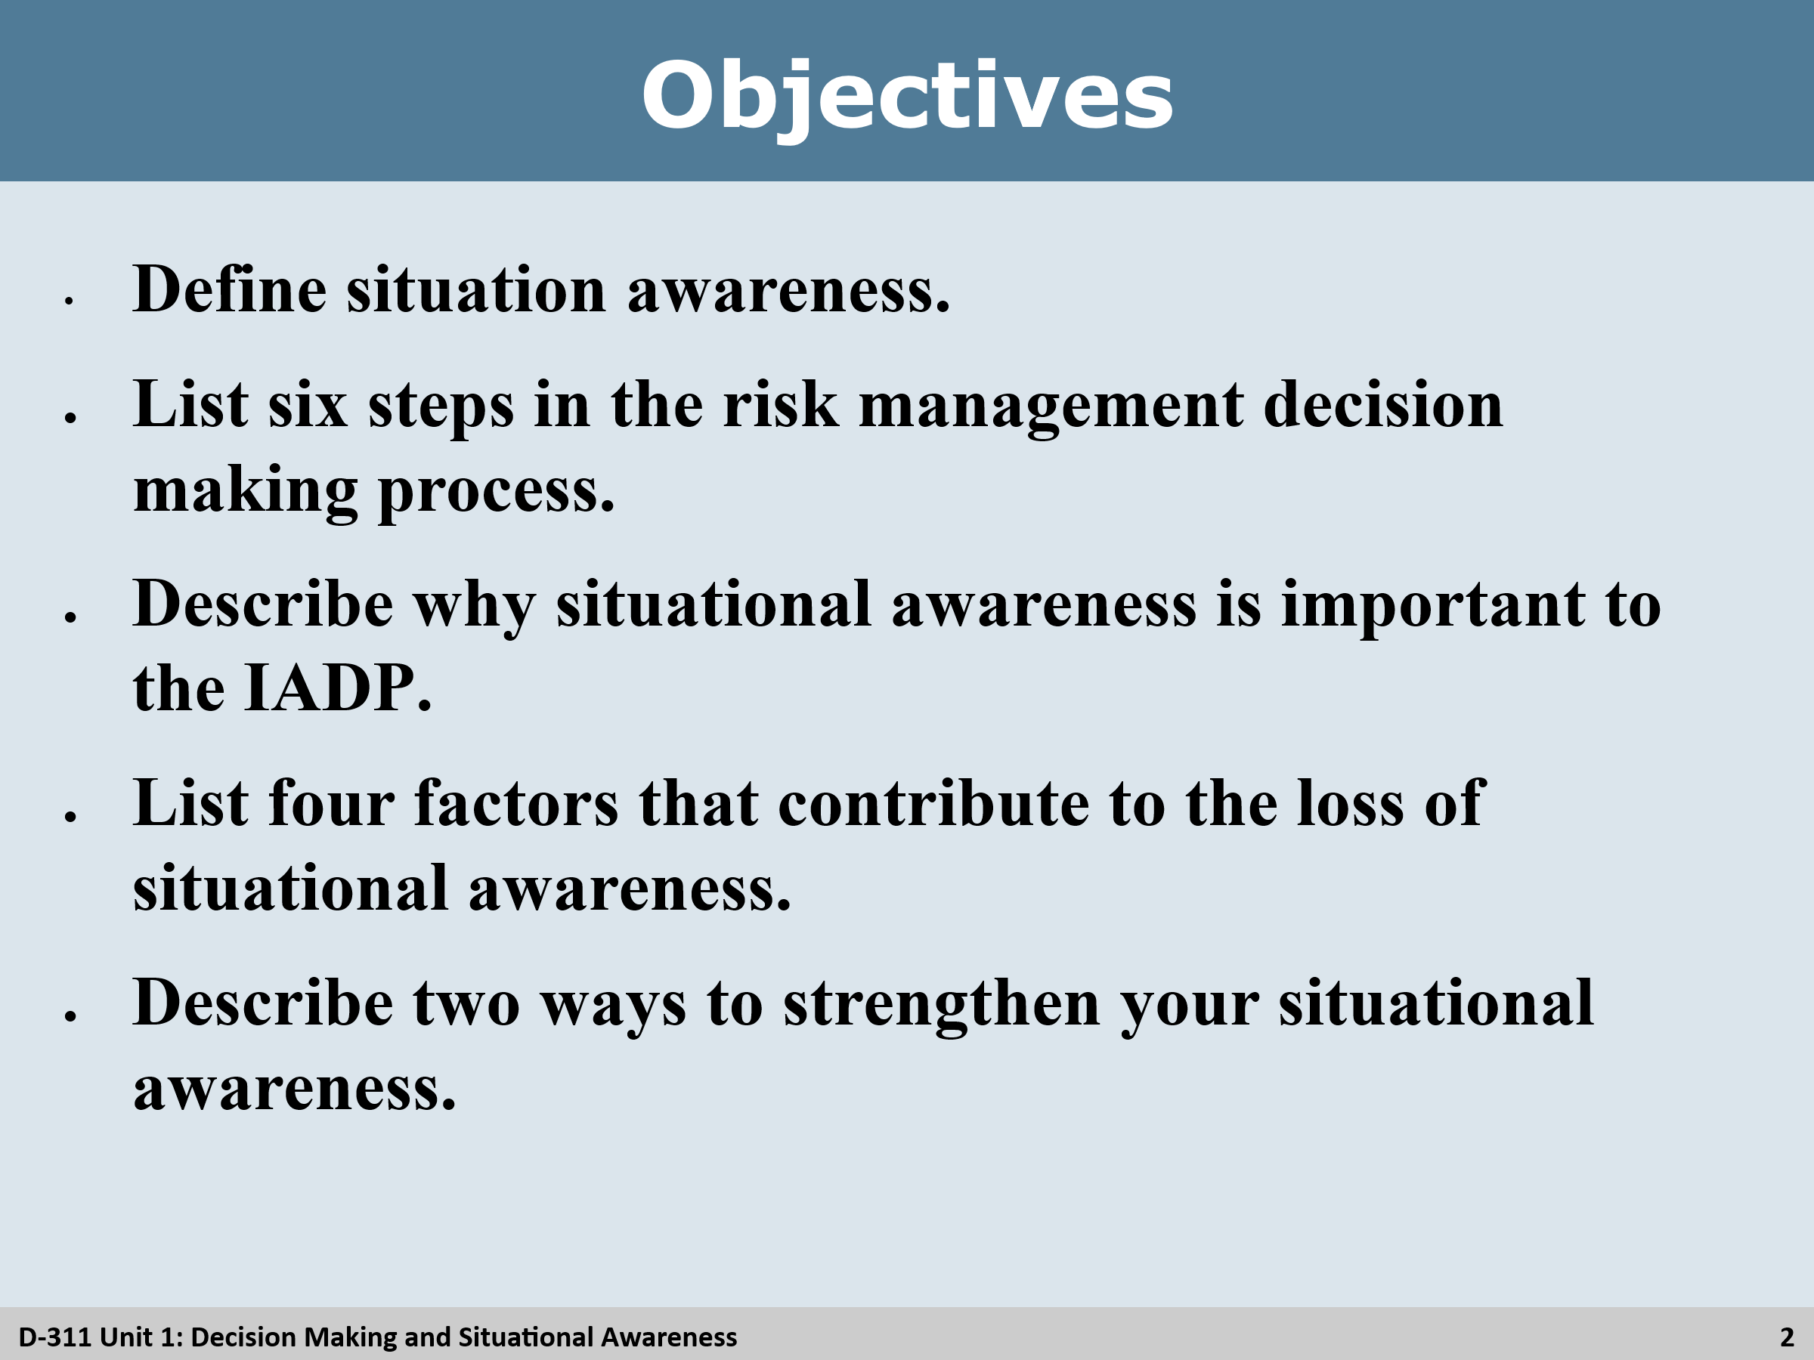

 Review Unit Objectives
- Refer the participants to the objectives as listed in the PowerPoint slide. Allow time for the participants to review.
- Present course goal and objectives

Slide 3 &4 What is Situational Awareness
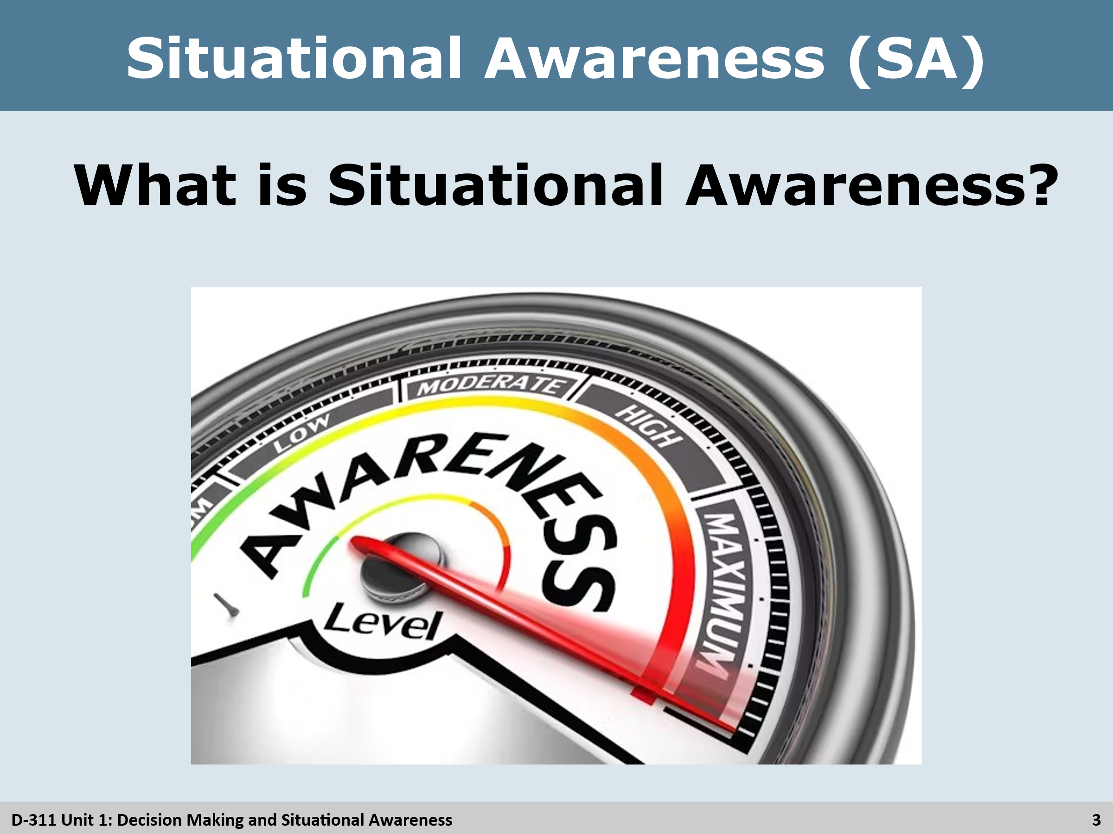
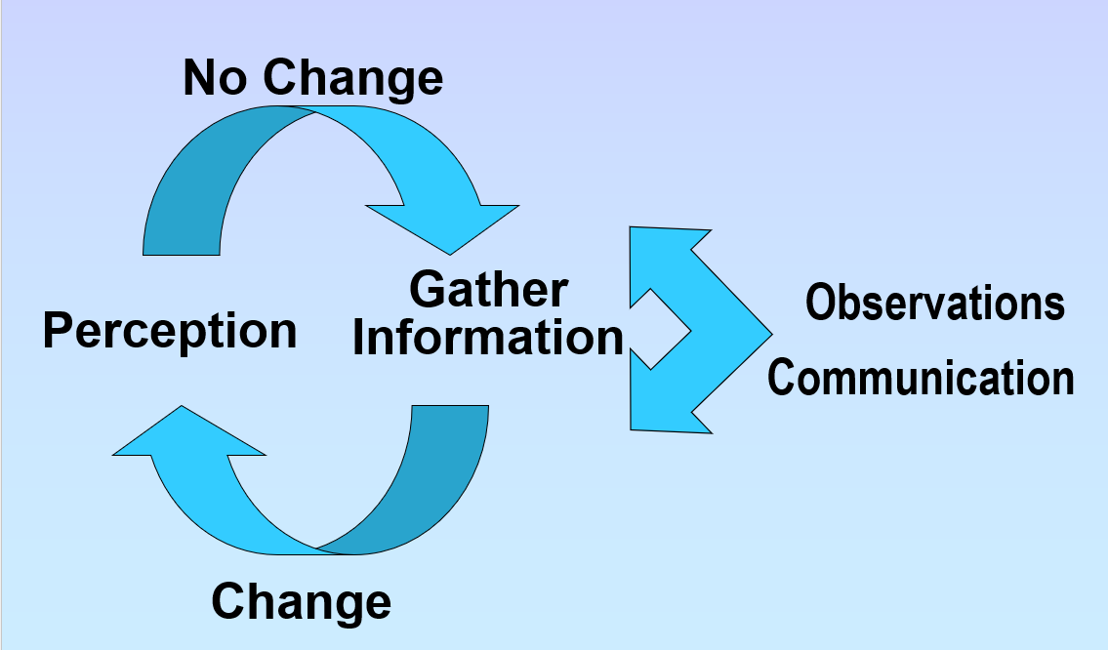
Situational Awareness
Situational Awareness
- What is Situational Awareness?
Group Discussion
Ask the class to define situational awareness:
- Situational awareness is how well your perception matches reality
- If your SA is high, you have a good perception of reality.
- True situational awareness occurs when an individual’s perception of reality and reality itself are the same.
- Your perception does not change the reality of the situation, so you must adapt.

Discuss the situation awareness cycle:

Slide 5 What is Perception
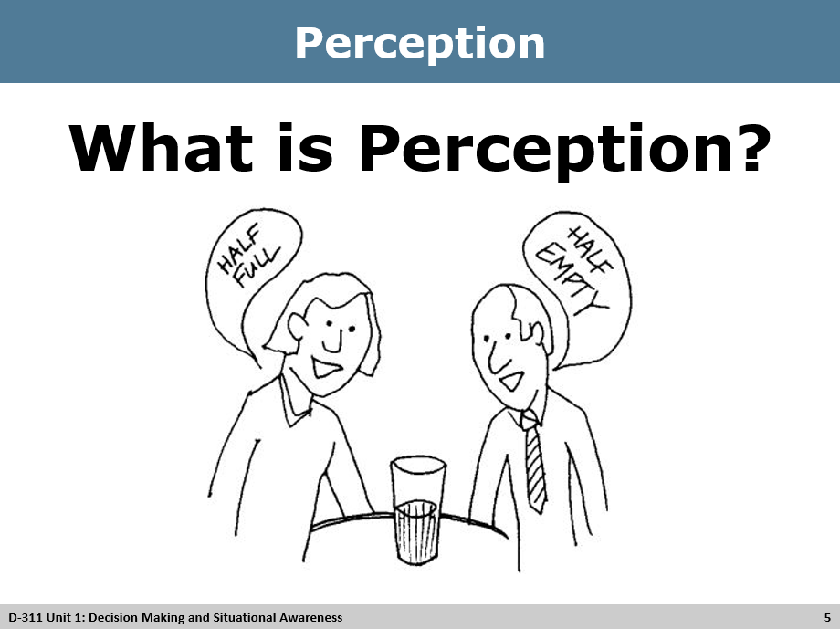
Discussion
What is Perception?
- Possible Answers:
  - Observation
  - Mental image
  - Concept
  - Consciousness
  - A capacity for comprehension
- Everyone starts with an initial perception of any given situation. Perception forms as a result of your experiences or attitudes.
- When you came to this class, you had an initial perception – call it a size up. Was it going to be challenging? Interesting?
- Your initial perception was only the starting point. Between then and now, you have continuously been updating your assessment – call it your perception.
- You have been gathering more information and changing your mental image about the situation.
- This cycle is called the situation awareness cycle, and it continues as long as you are awake and tuned in.

Slide 6 Information Gathering
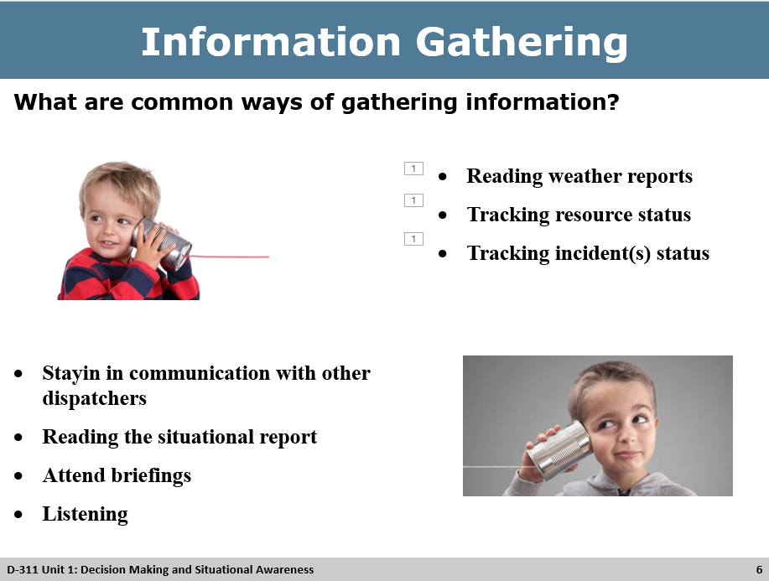
Information Gathering
- The only thing that changes perception is new information.
- You need to work at staying tuned in and make an effort to grab new information from an available source. Constant and conscious monitoring of the situation is required.
- Understand that your perception of reality sometimes differs from reality itself.
- This understanding should promote on-going questioning, cross checking, and refining or redefining of your perception.
Group Discussion
What are common ways of gathering information?
- Reading weather reports
- Tracking resource status
- Tracking incident(s) status
- Stayin in communication with other dispatchers
- Reading the situational report
- Attend briefings
- Listening

Slide 7 Importance of SA to an IADP
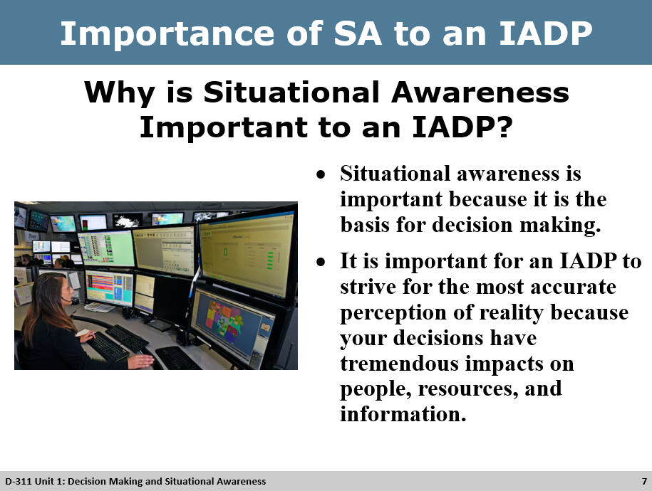
Group Discussion
Why is situational Awareness important to an IADP?
- Situational awareness is important because it is the basis for decision making.
- It is important for an IADP to strive for the most accurate perception of reality because your decisions have tremendous impacts on people, resources, and information.

Slide 8 Decision Making
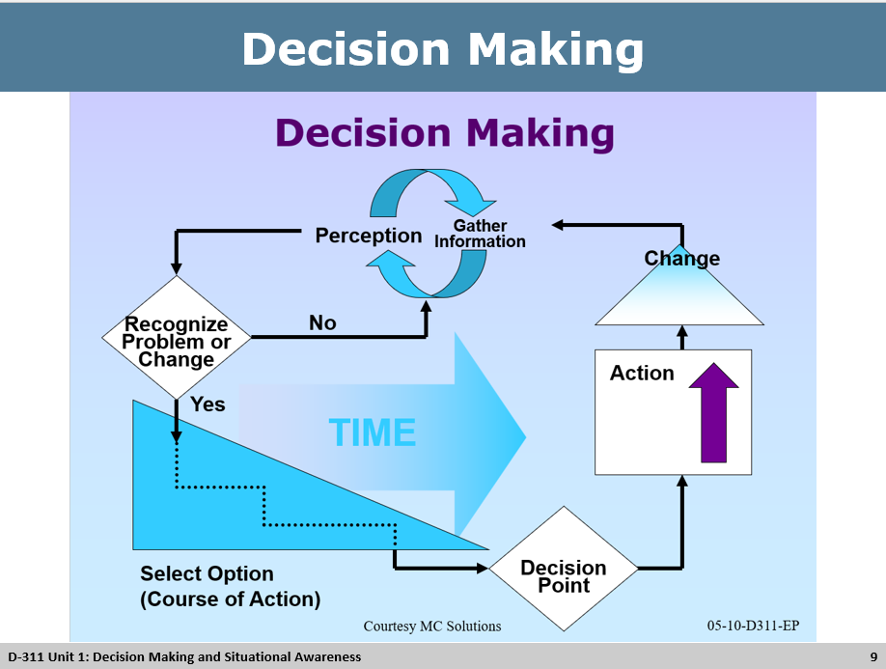
Decision Making Process
- If your perception of the situation is skewed, your decisions will be of little value and potentially harmful.

Slide 9 Six Steps to Decision Making
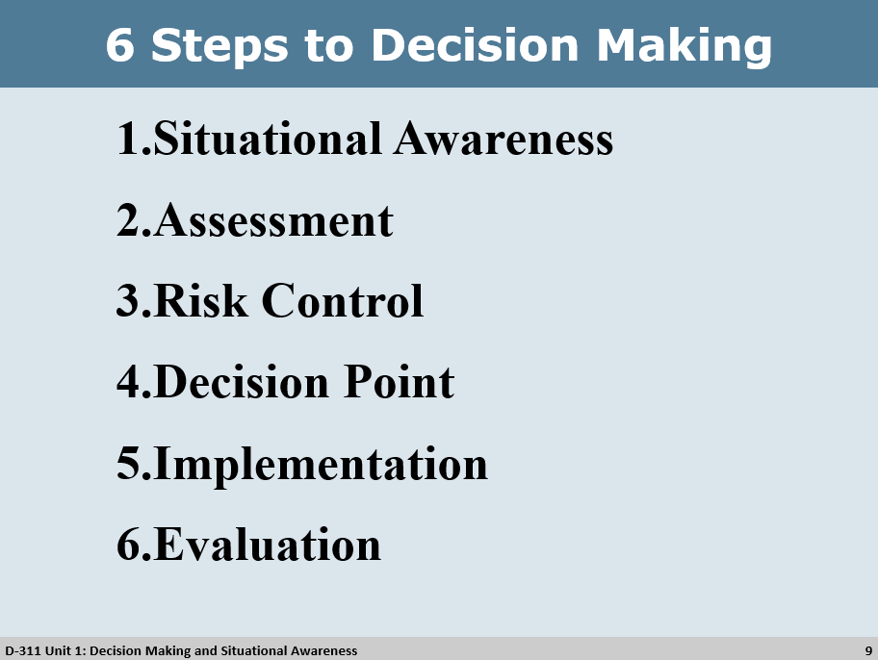
Group Discussion
The Scenario: Firefighters have arrived on scene of a new fire. They are gathering information and working through the 6 steps in the decision-making process.
Discussion around each step in the decision-making process.
- Situational Awareness
  - Forecast calls for dry lightning this afternoon and IA resources are already committed.
- Assessment
  - Given the forecast we will probably get more new fires.
- Risk Control
  - If I do nothing and we get more fires, we will have escapes and may have project fires. The risk is having multiple new starts with no available resources.
- Decision Point
  - I need to order more resources
- Implementation
  - Place orders and communicate your plan
- Evaluation
  - Did the plan work?

How is situational awareness acquired?
- Paying attention is one part of Situational awareness, but another big part is knowing what to pay attention to (knowing what is important).

Have the class give examples about rush hour traffic. Ask the class what indicators they pay attention to?
- Speed, other drivers, looking in mirrors, turning off the radio, rolling down windows, etc.

Have the class give examples of being in a dispatch center. Ask the class what indicators they pay attention to?
- Social cues, tone of voice, temperature, working hours, days worked, etc.

Slide 10 Three Key Components to SA
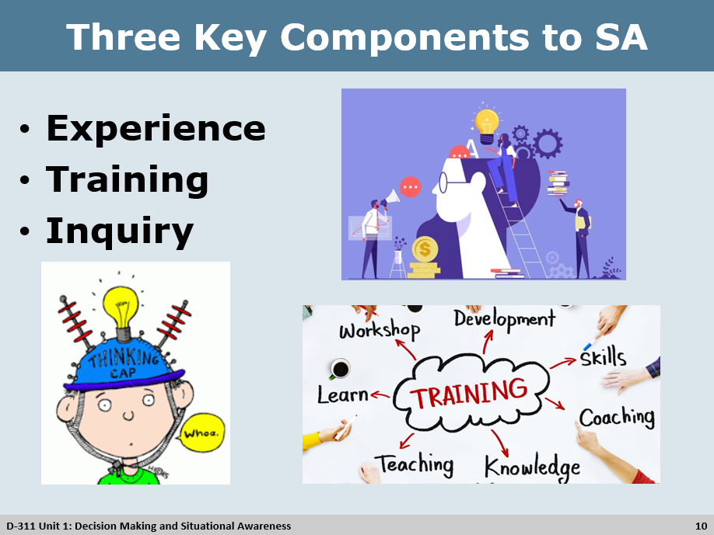
Three Key Components to Situational Awareness
- Experience
- Discussion Points:
  - Gather information on most important things.
  - Compares the current situation to your experience.
  - Experienced people have more slides
  - Speeds up the decision-making process.
Group Discussion

  - 40-year-old driver on slick roads vs. a 16-year-old driver.
  - A first-year firefighter’s approach to a fire vs a Type 1 IC’s approach.
  - A first-year dispatchers approach vs a center managers approach
- As an IADP on assignment, you need to be aware that it takes a few shifts to build your experience base. Your situational awareness may be low in new environments.

- Training
- Training adds to a dispatcher’s experience file by creating events that occur in dispatch offices under controlled circumstances. It creates more mental slides.
- Inquiry
- To change your perspective, you need new information. To get new information you need to inquire.
- Inquiry is questioning, scrutinizing, and investigating all that is happening. It is curiosity, skepticism, and interest. Inquiry is the opposite of complacency.
- Dispatchers who practice questioning, scrutinizing, investigating, and being curious can gain knowledge of a situation and recognize and acknowledge their beliefs and actions can be wrong and should continuously challenge them.

Group Discussion
What does Inquiry mean?
- Inquiry means respectfully being involved and helping as needed.
- Lack of visual cues can be a real challenge for situational awareness due to lack of expressions, tone inflections, etc.
- To compensate constantly check and double check your information.
  - Example: Engine 5 plots the fire over here; air attack plots it over there… this needs further investigation or inquiry.

Slide 11 Loss of Situational Awareness
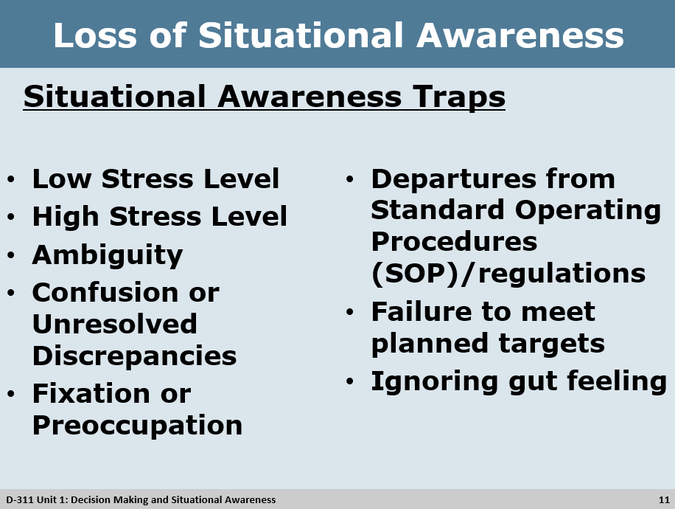
Factors that Contribute to the Loss of Situational Awareness
Situational Awareness Traps
- Below are some traps that can take away situation awareness if you allow yourself to fall into them. Knowing they are there will help you avoid them.
Group Discussion
- Low stress level
  - In periods of low activity situational awareness could be low due to boredom and fatigue brought on by significant decline in activity.
  - The lack of alertness results in the inability to react quickly and efficiently to an emergency.
- High stress Level
  - Information overload
  - Personal stress
  - Environmental
- Ambiguity
  - A situation in which something has more than one possible meaning and may cause confusion.
    - Order a heavy could mean Type 1 Helicopter or Heavy Airtanker
- Confusion or unresolved discrepancies
  - Unclear information
  - Conflicting reports of fire location
  - Conflicting call signs

- Fixation or preoccupation
  - Tunnel vision
  - Focused on one incident and not listening to the other repeaters
- Departures from standard operating procedures (SOP)/regulations
  - Unexpected situations
  - Deviation from the run card
  - Power / radio outages
  - Wilderness areas
- Failure to meet planned targets
  - Missing daily routines
  - Morning weather
  - Shift briefing
  - Sit report
- Ignoring gut feeling
  - Questioning your best judgement
  - Recognize your own signs and trust your feelings

Slide 12 How to Strengthen SA
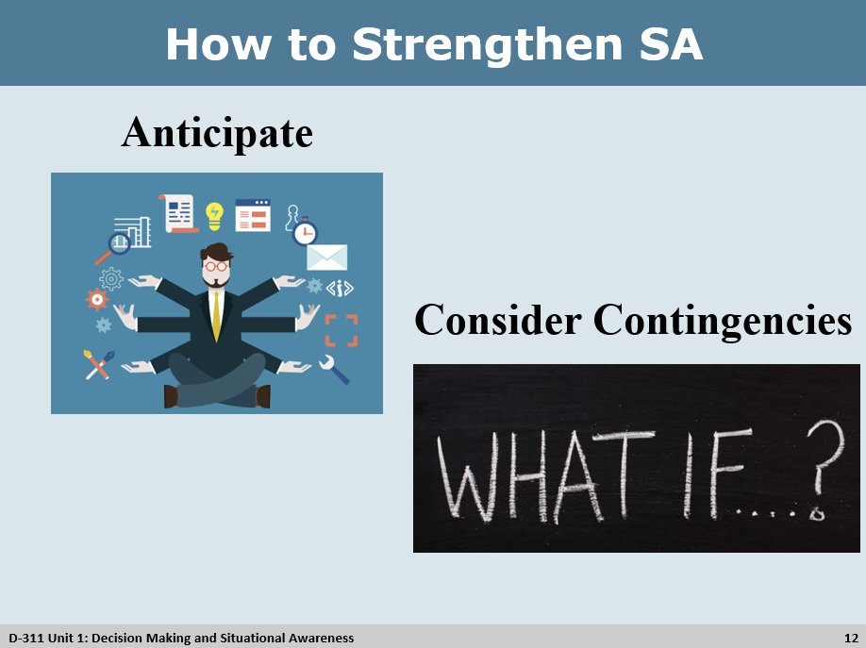
How to Strengthen Situational Awareness
How to strengthen Situational Awareness
- Anticipate
  - Stay ahead of the events
  - Think things through ahead of time
  - Divide tasks and information
  - Consider both immediate future and the long term
  - Incoming weather
  - Short staffing
  - Logistics of an incident
Group Discussion
Consider Contingencies
Brainstorm a few “what if” scenarios with the students. Have someone volunteer a situation or use one of your own and work through a few contingencies with the class.
- What if?
  - What if the helicopter has a mechanical problem and we can't get folks off the hill by dark?
  - What if we lose the three new starts and they go to extended attack?
  - All our resources are committed on the south end, what if we pop something on the north end?
  - Important to share your vision with your co-workers so everyone is working off the same plan.
  - Have students come up with contingency actions for above questions.
  - Sometimes things happen that cannot be anticipated. These can be accidents, system malfunctions, or simply a normal event at an unexpected time. What will you do?
  - Check SOP’s
  - Communicate your needs
  - Get help

Slide 13 Summary
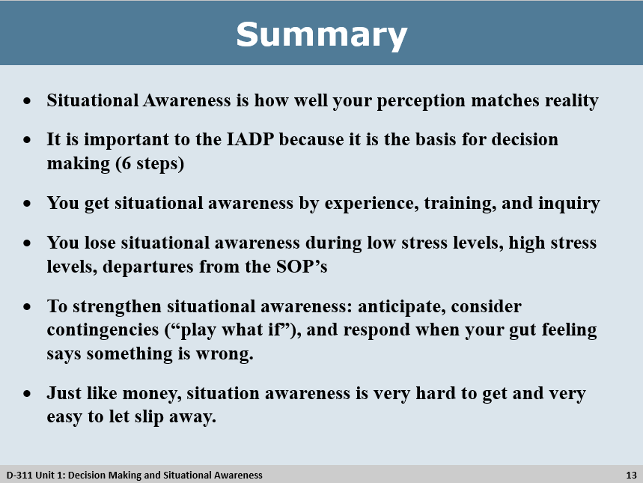
Summary
- Situational Awareness is how well your perception matches reality
- It is important to the IADP because it is the basis for decision making (6 steps)
- You get situational awareness by experience, training, and inquiry
- You lose situational awareness during low stress levels, high stress levels, departures from the SOP’s
- To strengthen situational awareness: anticipate, consider contingencies (“play what if”), and respond when your gut feeling says something is wrong.
- Just like money, situation awareness is very hard to get and very easy to let slip away.

Slide 14 Objectives
